**Design Document**

Feeler

Index

2 Introduction 3

2.1 Document goal 3

2.2 References 3

3 Project description 4

3.1 Concept 4

3.2 Technology choice 4

4 Design 5

4.1 General info 5

4.2 Colors 5

4.3 Logo 5

4.4 Font 6

4.5 Prototype 7

# Introduction

## Document goal

This document will define and document the application’s front-end design at a concrete level.

## References

Where needed, this document will reference any external documents, but all documentation and code can be seen here: [documentation](https://github.com/RDieleman/feeler-documentation), [frontend code](https://github.com/RDieleman/feeler-frontend), [backend code](https://github.com/RDieleman/feeler-backend).

# Project description

The entire analysis of the project - including detailed requirement and userstories – can be found [here](https://github.com/RDieleman/feeler-documentation/blob/main/Analysis%20Document.pdf).

How the front-end application fits into the entire project can be seen [here](https://github.com/RDieleman/feeler-documentation/blob/main/Architecture%20Document.pdf).

## Concept

When starting this project, a first iteration of the application existed. This project expands further upon this first project. The following points in the final, complete, concept are relevant for the design:

* The user can explore books based on an emotion,
* The user can read details about books.
* The user can store books they want to read in their bookshelf.
* The user can set the status of books on their bookshelf to reading and read.
* The application is available in English.
* The front-end application is optimized for mobile devices.
* The user can register and authenticate.
* The user can search for books by title, author or ISBN.
* The user can delete their account.
* The user needs to be complemented when finishing a book.
* The user can explore random books.

## Technology choice

The front-end application is a progressive web application using React.

Something that comes with this is that the front-end application should provide an install button.

# Design

## General info

|  |  |
| --- | --- |
| Name | Feeler |
| Description | Don’t mind the books. |

## Colors

The design uses the following color palette, which can be found in-detail and interactive [here](https://github.com/RDieleman/feeler-documentation/blob/main/designs/colors/feeler%20-%20color%20palette.pdf).

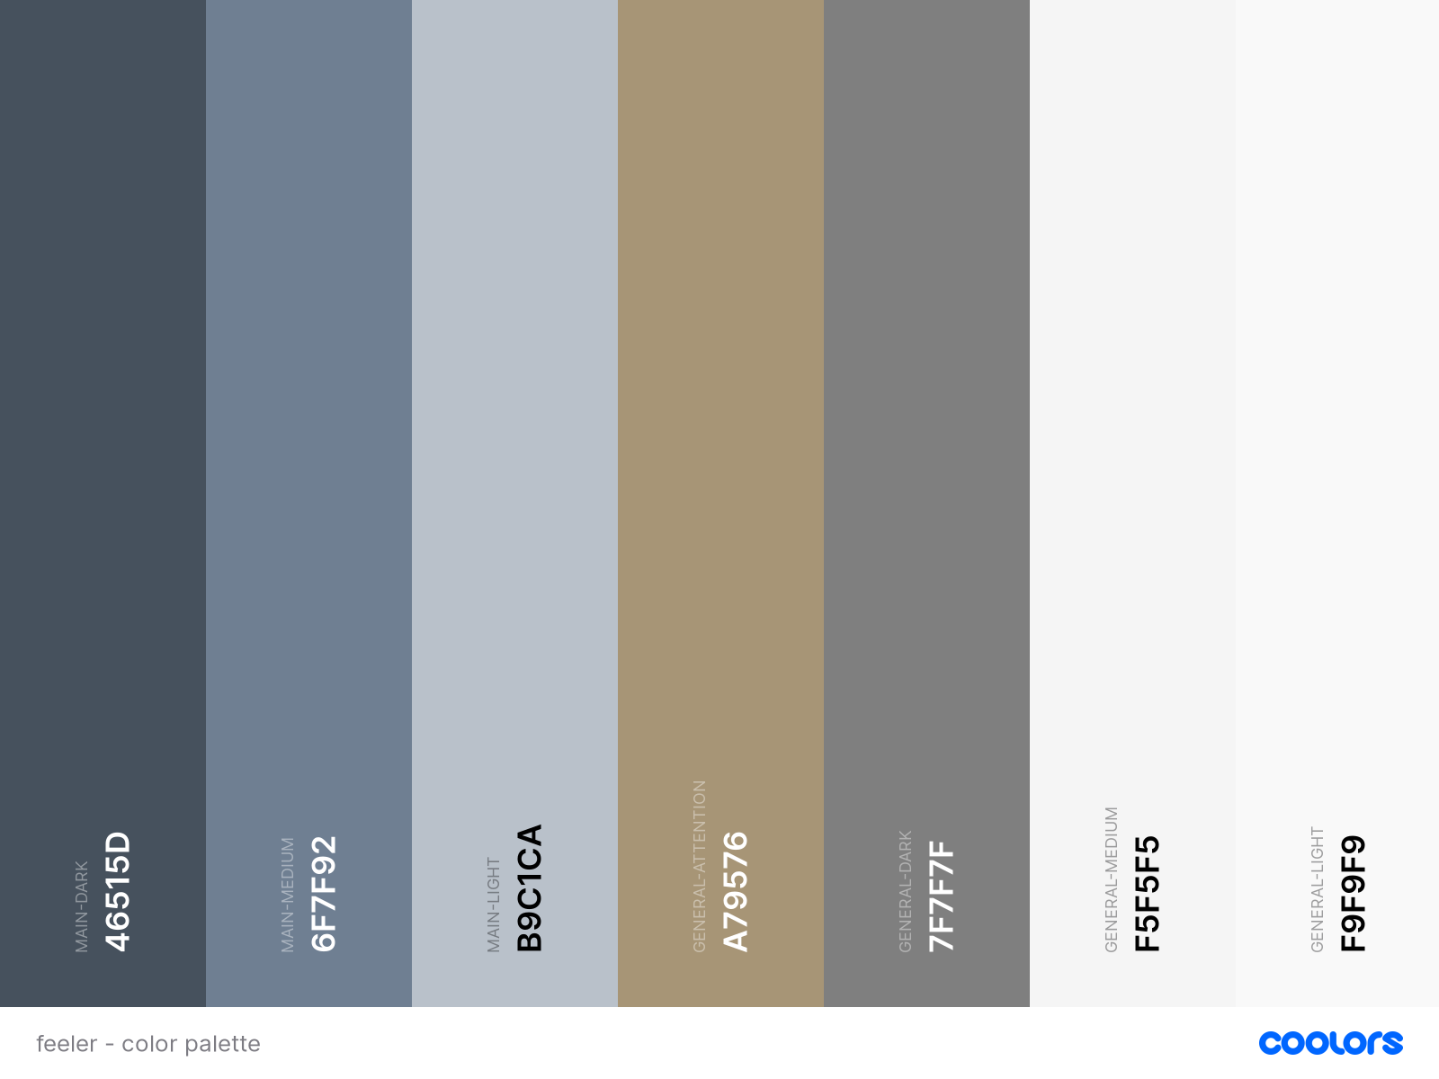

## Logo

The following image is the logo for the project. All original images and SVG files can be found [here](https://github.com/RDieleman/feeler-documentation/tree/main/designs/logo).



## Font

The font used in the design is Roboto – which can be found in-detail [here](https://fonts.google.com/specimen/Roboto).

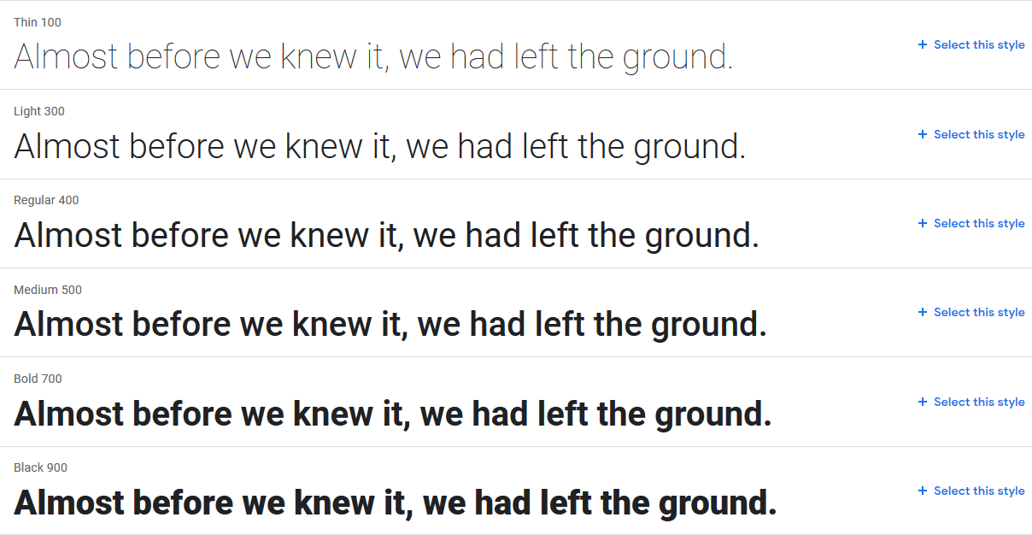

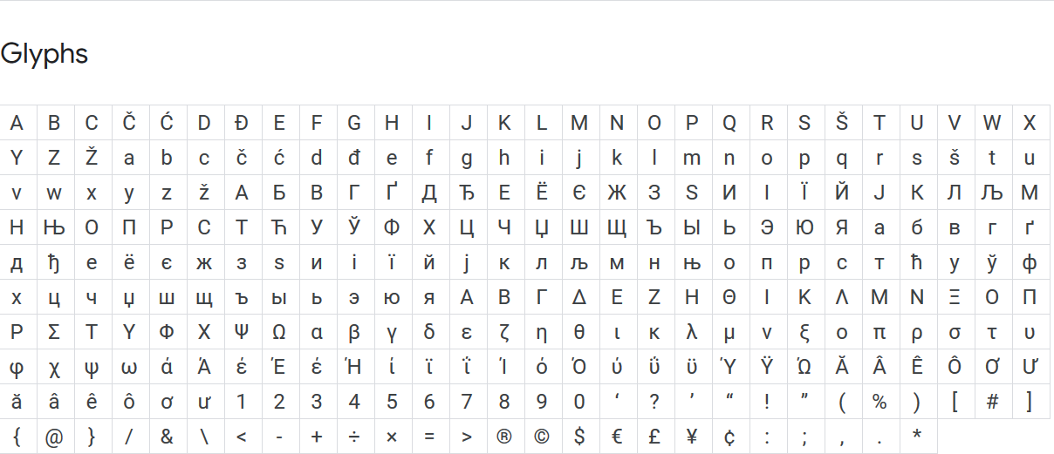

## Prototype

The prototype was created using Adobe XD. The full, interactive, design can be found [here](https://github.com/RDieleman/feeler-documentation/blob/main/designs/Clickable%20Prototype.xd).

